1. First of all, I need to generate a list of product’s url to retrieve information from. Basically, when we enter Sephora’s website, we’ll need to i. look under ‘Brands’ to locate the brand, ii. click on the specific brand to get to the list of products, and iii. click on the specific products to retrieve information.

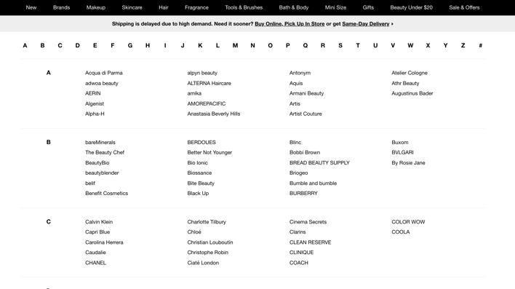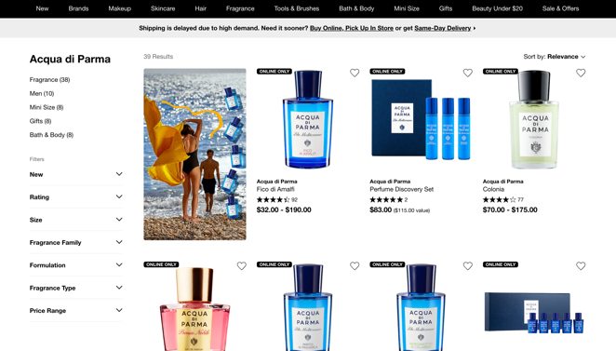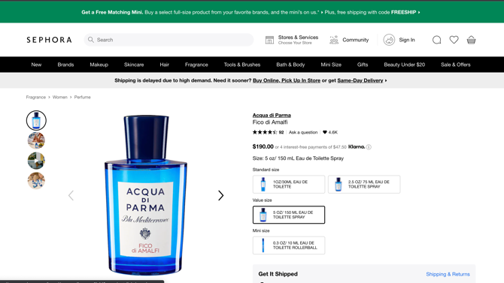

AWS: learn S3 bucket to trigger lambda function and transfer data to RDS (relational data base)

GCP: learn storage bucket to trigger cloud function and transfer data to cloud SQL (or BigQuery)

ETL = Extract Transform Load

SQL